Report Documentation of the First Module of the Transfer Learning project on Feature Selection based Dynamic Ensemble Model

The transfer learning is applied on the given customer churn dataset, basing on the features selected. The procedures are applied in the following ways:
- The First Feature Selection: The first feature selection is performed on the whole dataset using linear Support Vector Machine, which runs in linear time. For a linear SVM, the feature importance can be derived from the weight vector of the hyper-plane, a procedure known as Recursive Feature Elimination SVM (SVM-RFE). The SVM-RFE ranks the features, and the best 10 features are selected from the dataset. Lower the rank, better is the attribute.
The hyper-plane is constructed using only the support vectors (i.e., data that lie on the margin). The general form of the hyper-plane is represented as
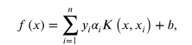
where the training set is of size 𝑛, 𝑥𝑖 is the input data of sample 𝑖 ( 𝑖 = 1 , 2 , … , 𝑛 ), 𝛼_{𝑖} is the Lagrange multiplier solved from the training set. 𝑦_{𝑖}∈ ( − 1 , 1 ) is the class label for sample 𝑖 , 𝐾 ( 𝑥 , 𝑥_{𝑖}) is the kernel function, x is the variable vector of a sample, and 𝑏 can be viewed as intercept. The optimized weight vector equals to
,
where 𝛼_{𝑖} is nonzero if 𝑖 belongs to support vector, otherwise 𝛼_{𝑖} equals to 0, and 𝜙 ( ⋅ ) is a nonlinear mapping function from input space to feature space.

The Output is displayed as follows:
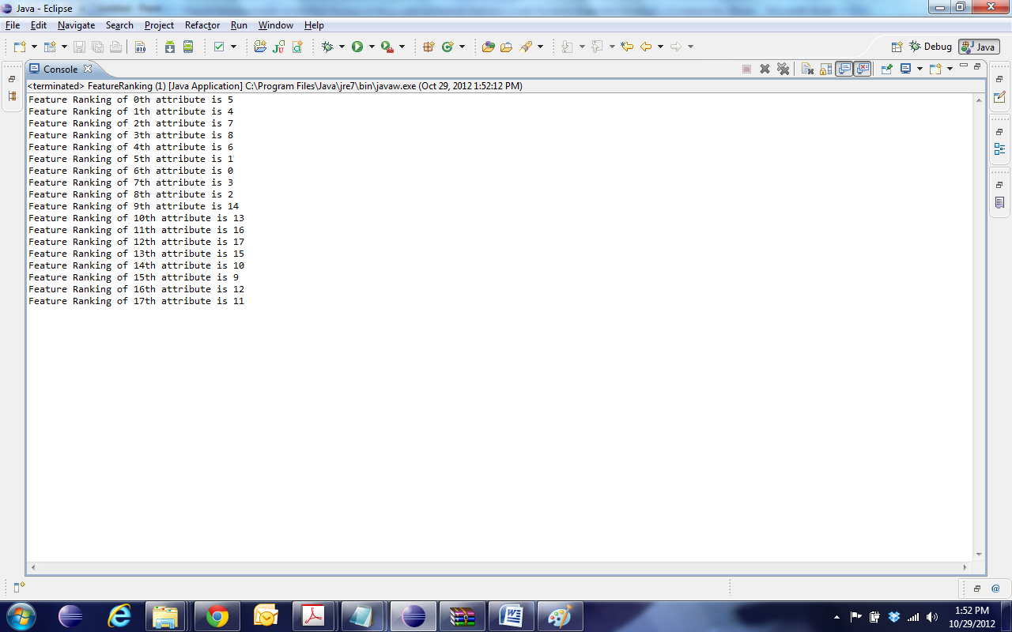
- The Second Feature Selection: The Second Feature Selection is performed by Greedy Forward Selection Method on the features selected by the First Feature Selection. The Greedy Forward Selection selects 5 best subset features from the 10 features selected by the SVM-RFE.

The output is displayed here:
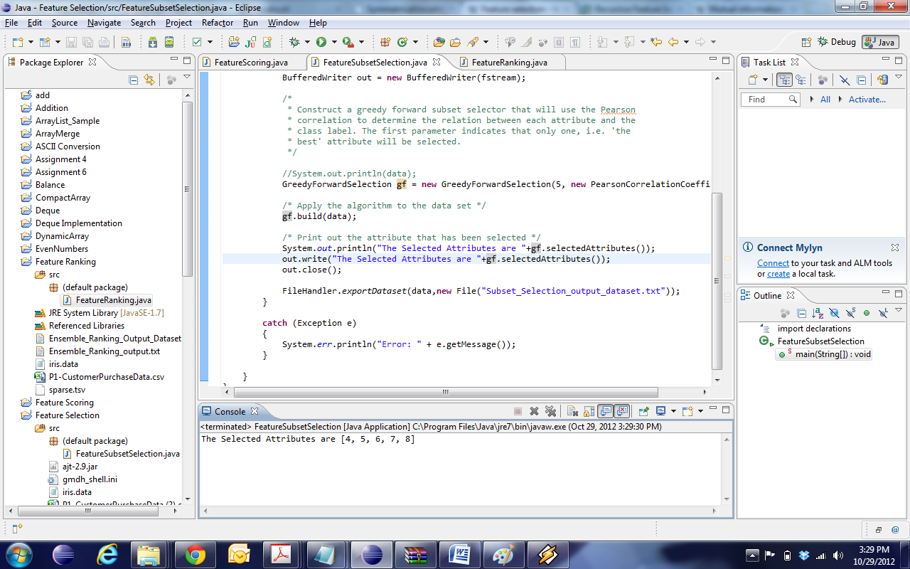

- The Third Feature selection: The Third Feature Selection is performed using Symmetric Uncertainty Algorithm. Symmetric uncertainty is determined by the given formula:
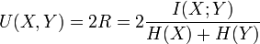
which represents a weighted average of the two uncertainty coefficients. Here,
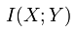represents the mutual information of two discrete random variables X and Y
Symmetric Uncertainty scores the features based on the algorithm, and finally the best feature is selected. Higher the score, the better is the attribute.
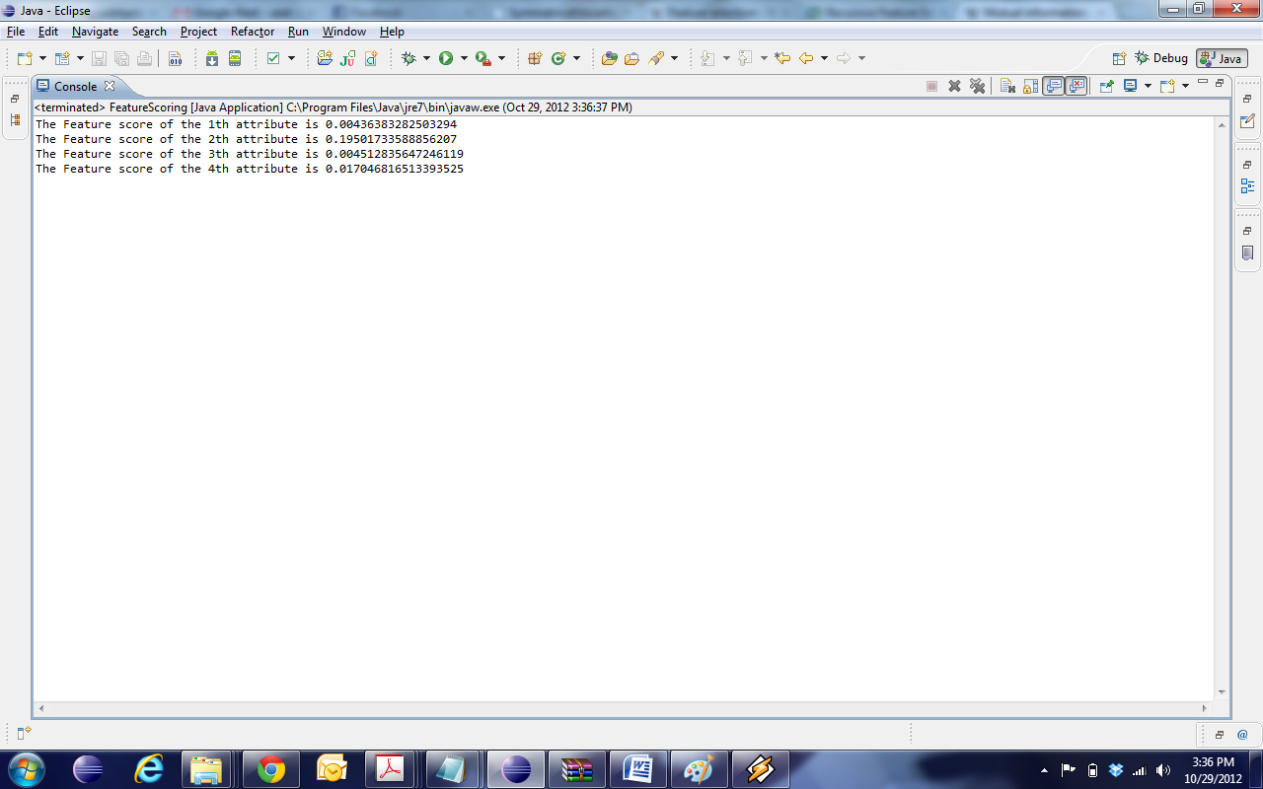

Analysis: In accordance with the feature selected by transfer learning using all the three mechanisms, the best feature is “Weeks since First Purchased” followed by the “Books Purchased” Feature.
Run Times: The SVM-RFE runs in linear time O (n), whereas the Greedy Forward Selection and Symmetric Uncertainty runs in Exponential time O (n log n)

References:
- http://en.wikipedia.org/wiki/Feature_selection
- http://www.hindawi.com/journals/cmmm/2012/712542/
- http://en.wikipedia.org/wiki/Mutual_information

